Laporan UTS Teori
Pemrograman Berorientasi Objek (PBO)

Membuat UML Class Diagram (wajib): Character (abstract), Enemy (abstract), Player, Monster, BossMonster, Skill (interface), StatusEffect (interface), AttackStrategy (interface), Battle.

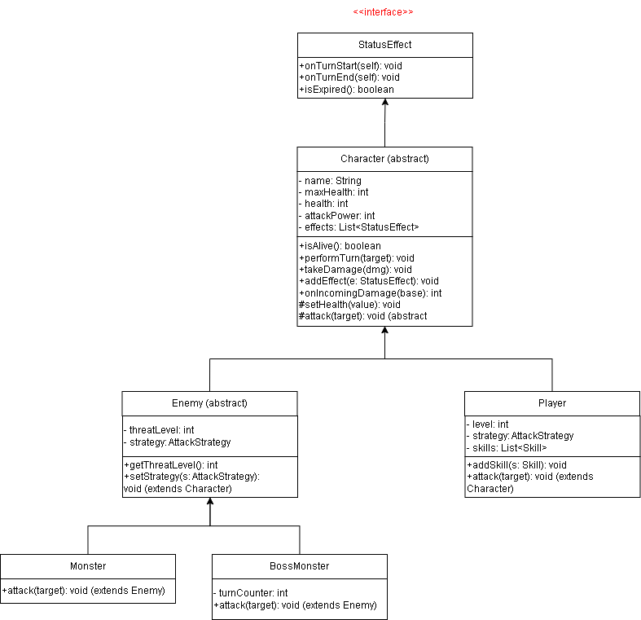
Jawab :
